**Milestone 2: Service Creation**

Activity 1: Creation

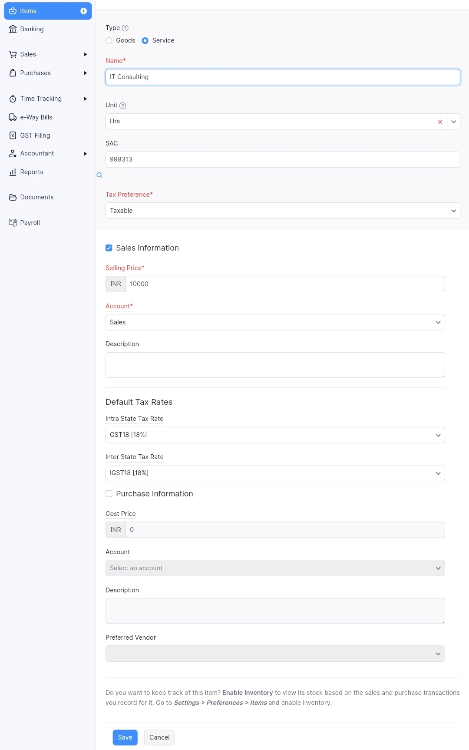

Activity 2: Review of Items after Addition

